**Contents**

**Students & Visitors…………………………………………………………………………….2**

**Water Sources………………………………………………………………………………………3**

**Home visits……………………………………………………………………………………………..5**

**Quarterly Trainings…………………………………………………………………………….6**

**Health Centre Visits……………………………………………………………………………7**

**School Program…………………………………………………………………………………..8**

**Hypertension………………………………………………………………………………………….8**

**The Cook stove Project…………………………………………………………………….9**

**World Malaria Day………………………………………………………………………………11**

**Stories from the Field……………………………………………………………………..11**

**A.O.B……………………………………………………………………………………………………….12**

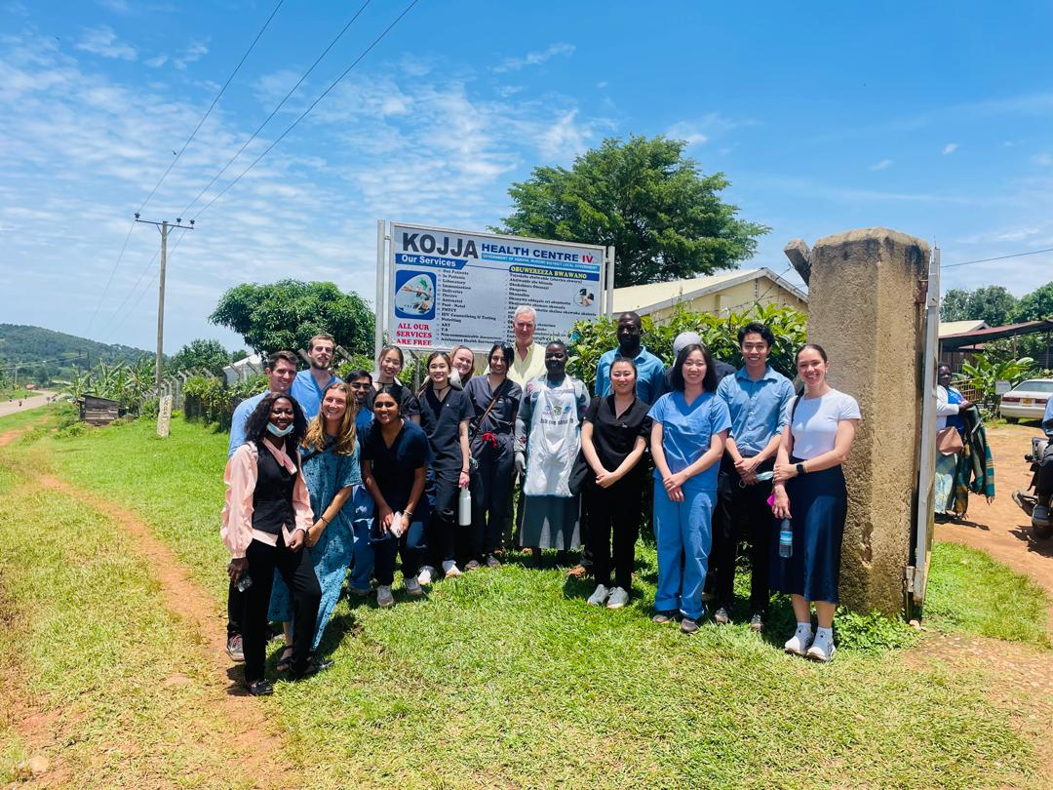

**Students & Visitors**

This month we hosted a group of GW Medical students and Rebecca Zacuto, Program manager office of international medicine programs at the George Washington School of Medicine. They stayed with us for a week. During their time with us, they actively engaged and contributed to Omni Med activities. They participated in a cook stove demonstration, visited an unprotected and protected water source, attended home visits and quarterly training sessions, conducted community hypertension screenings, visited a local health center, and taught in our school program. We were pleased to host them.

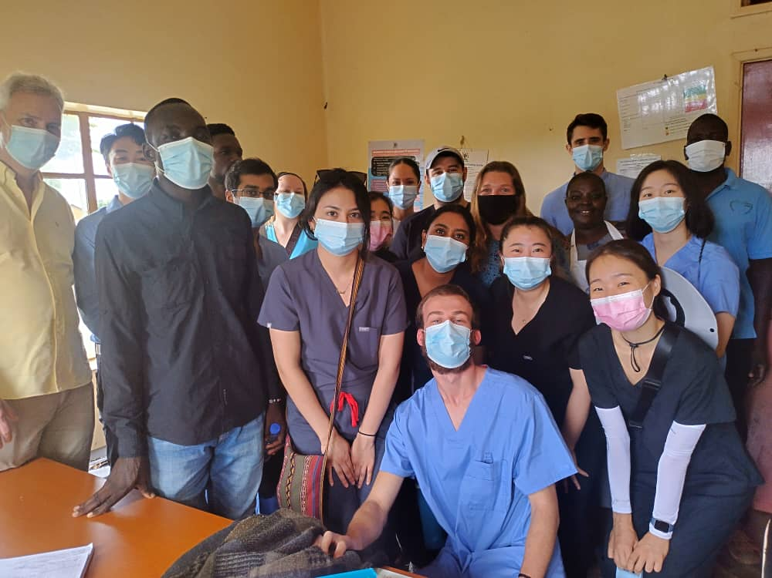

*GW Medical students with Omni Med staff after an interaction with the clinician at Kojja H/C IV*

We also hosted our founder and president Dr. O’Neil for two weeks. During his visit, he engaged extensively with staff, discussing ongoing programs, and future initiatives. We welcomed the opportunity to have him with us.

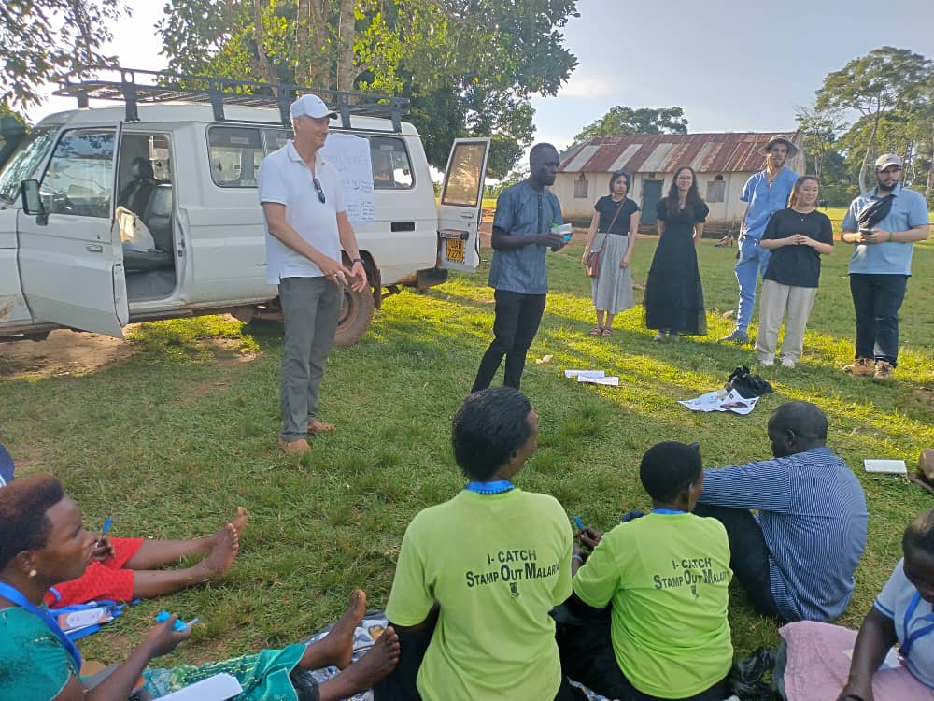

*Dr. O’Neil (standing on the left) speaking with VHTs of Bunakijja Parish*

**Water Sources**

Omni med staff visited four water sources in the month of April.

During the GW medical students’ stay, they visited local water sources in the villages of Kiteza, Kirondo and Makata including unprotected open water and protected sources like springs and boreholes. They learned notable differences between the two protected water sources- boreholes can be constructed almost anywhere, whereas springs require an available natural open water source. This flexibility makes boreholes more accessible to vulnerable populations, such as the physically disabled or pregnant mothers. However, they are prone to breakdown and come with higher construction costs.

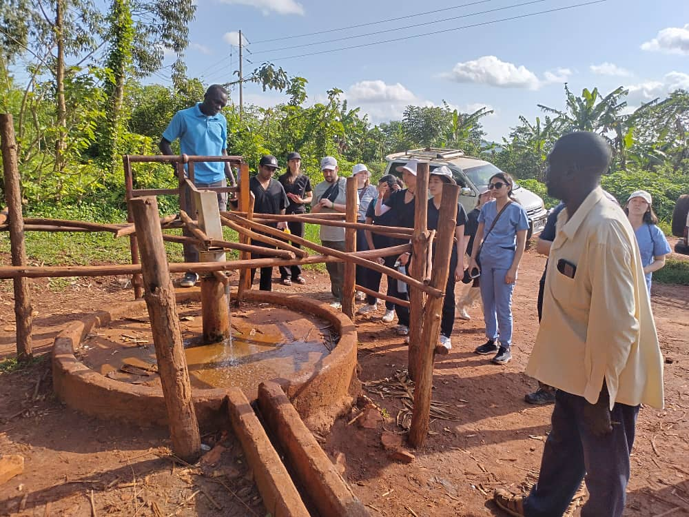

*GW Medical students and Omni Med staff at the borehole in Kirondo village*

In contrast, springs are generally more durable and affordable, but their locations can be limited by geography, and accessibility can be challenging in hilly areas, particularly for those with mobility issues. The students showed great interest in the springs, asking many questions about sustainability, maintenance and their role in the community’s water supply. They were amazed by the natural beauty and importance of these water sources to the community.

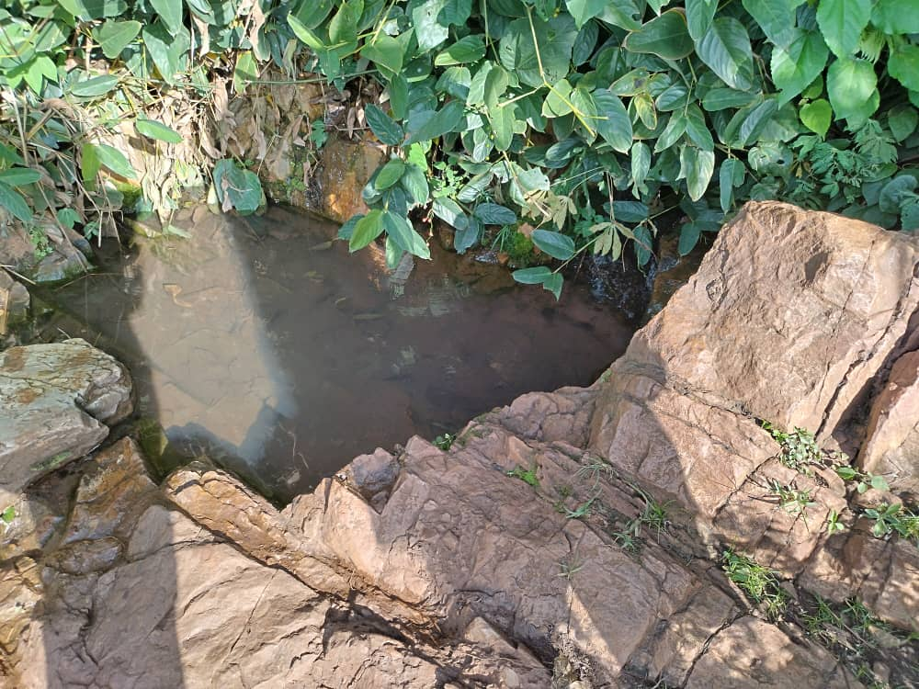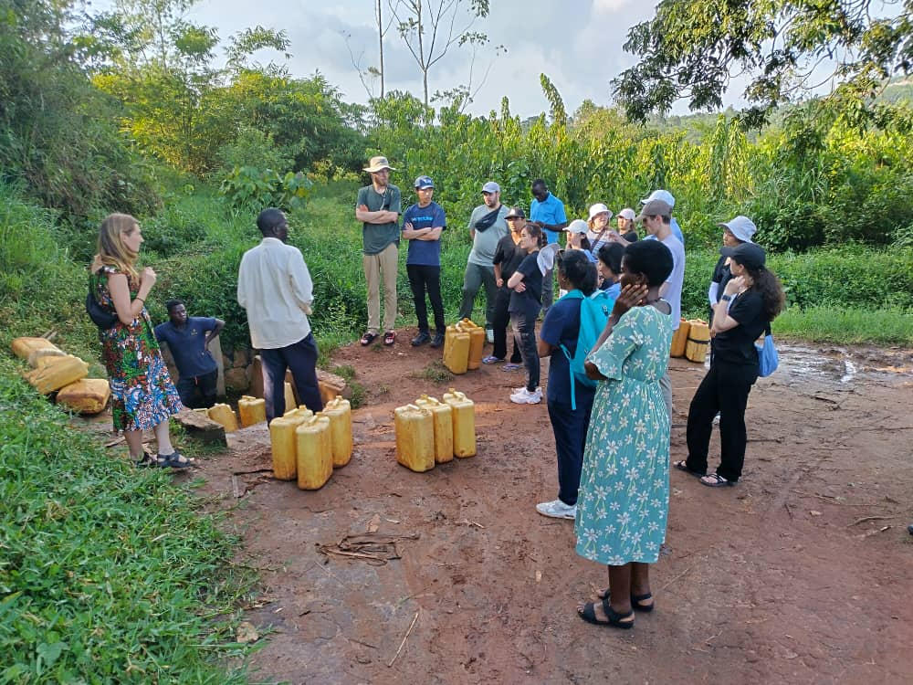

*An open water source(L) in Kiteza village and GW Medical students and Omni Med staff (R) visiting a spring in Makata village*

Our staff visited a protected water source in Gonve village, Nsanja parish, constructed by the RUWASA Project in March 1995. Remarkably, this well-functioning water source serves over 180 households with a strong flow from its two pipes. This highlights the durability and lasting impact of well-constructed water sources. 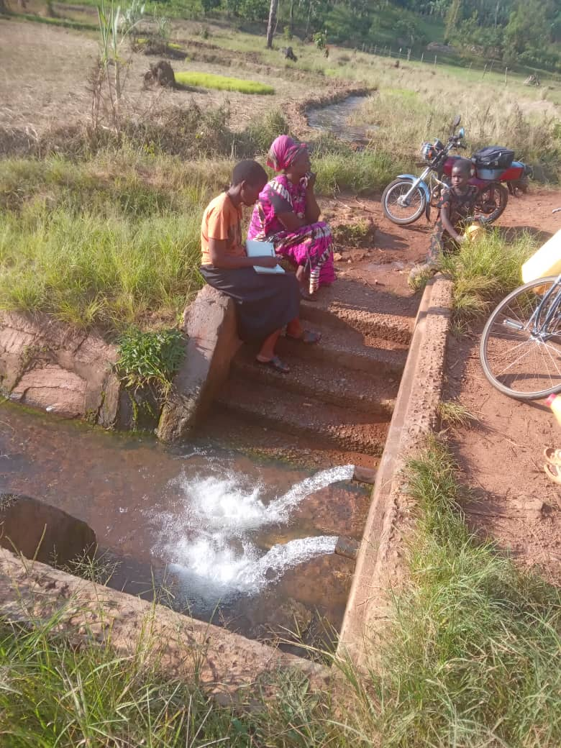

*Our staff Cissy and Ruth visiting a protected water source in Gonve village*

**Home visits**

This month we held 10 home visits and saw 24 VHTs.

**Breakdown of home visits for April**

| **DATE** | **VILLAGE** | **NO. OF VHTS SEEN** |
| --- | --- | --- |
| 1-APRIL | KISOGA A | 2 |
| 1-APRIL | KISOGA B | 2 |
| 1-APRIL | KISOGA C | 3 |
| 1-APRIL | MPUMU | 4 |
| 1-APRIL | LUGA | 4 |
| 1-APRIL | MPOLOGOMA | 2 |
| 15-APRIL | LUGOBA | 1 |
| 17-APRIL | BUGOYE | 2 |
| 22-APRIL | MUGOMBA | 2 |
| 22-APRIL | MIREMBE | 2 |

Average number of households that VHTs serve: 95

Average number of years each VHT has served in their village: 15

Commonest occupations of VHTs: Farmers, Small scale business owners, Tailors.

Common changes: More pregnant women receive antenatal services from health centers, Increased use of family planning, General improvement in sanitation and hygiene, More people boiling drinking water, Increased construction of drying racks, Decrease in diseases like malaria, diarrhea, measles and other vaccine-preventable diseases, Increased participation in immunization programs, Increased use of mosquito nets, Increased construction of pit latrines, Increased number of people seeking medical care from health centers.

Suggested topics by the VHTs: HIV/AIDs counseling, Nutrition, HIVAIDs, Ulcers, Immunization, Prostate Cancer, Healthy pregnancy, Mental Health, Diabetes, Hypertension, Family planning, Tuberculosis, Malaria.

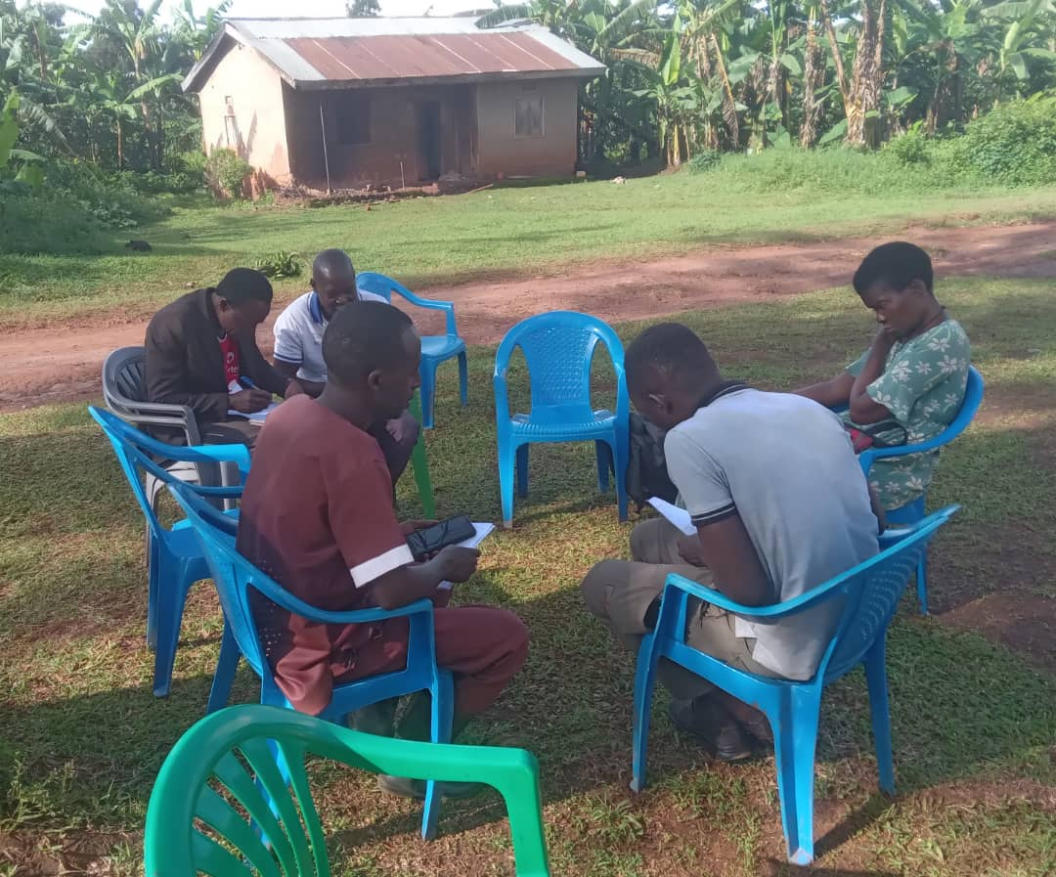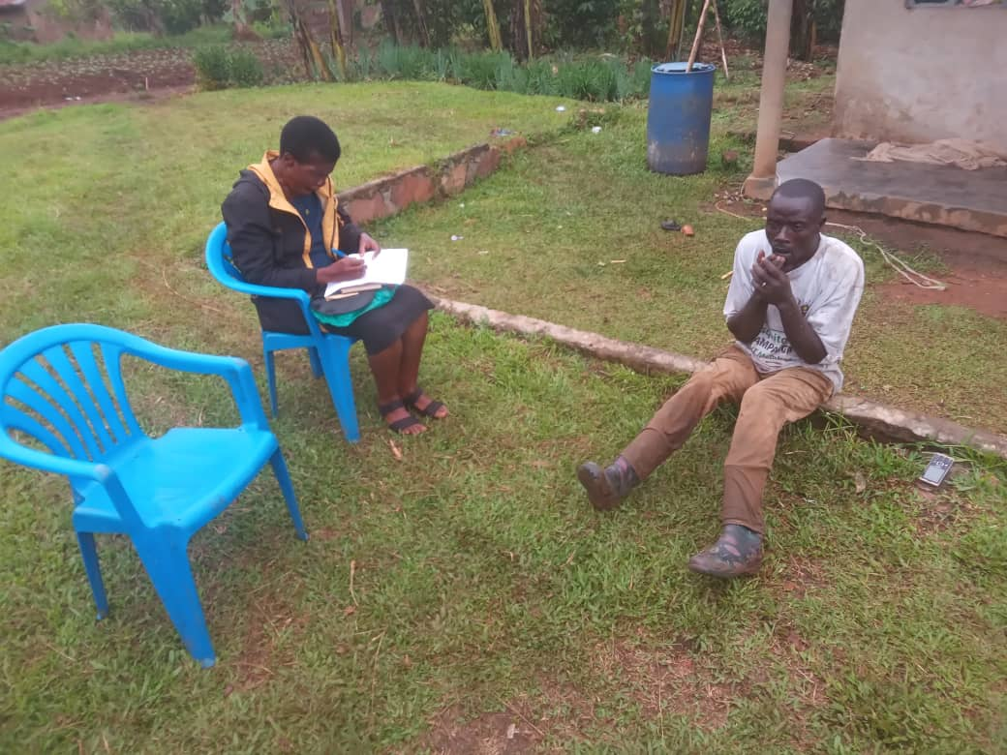

*Our staff with VHTs during home visits*

**Quarterly Trainings**

Omni med staff held 4 quarterly trainings in the month of April.

**List of Quarterly Trainings held in April**

| **DATE** | **PARISH** | **NO. OF VHTS** | **TOPIC** |
| --- | --- | --- | --- |
| 3- APRIL | BUNAKIJJA | 15 | MENTAL HEALTH |
| 3- APRIL | NSANJA | 32 | MENTAL HEALTH |
| 16- APRIL | BAMUSUUTA | 13 | MENTAL HEALTH COPING SKILLS |
| 23- APRIL | NABALANGA | 07 | MENTAL HEALTH COPING SKILLS  ORTUBE TRAINING & DISTRIBUTION |

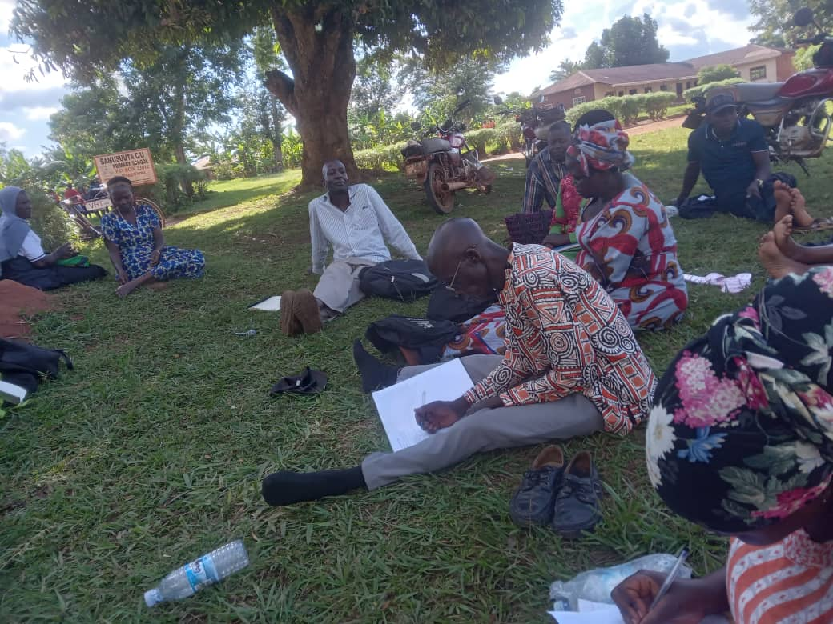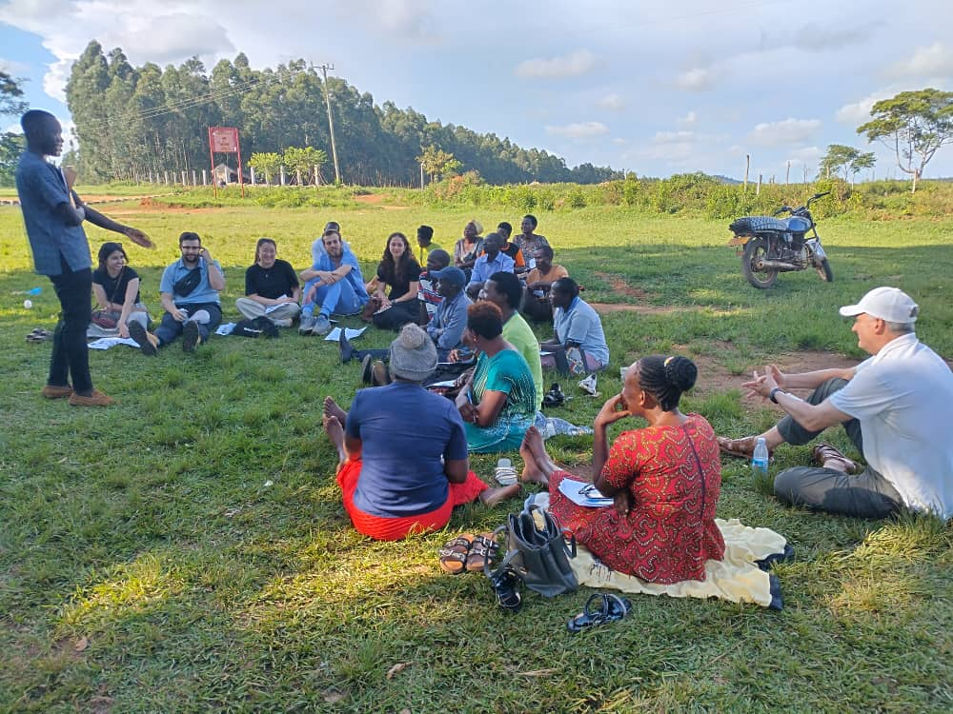

*Our staff with some of the VHTs during quarterly trainings*

**Health Centre Visits**

The George Washington Medical Students had the opportunity to visit Kojja H/C IV, a health care facility that provides essential medical services to the local community. During their visit, they met with the clinician and the officer in charge, who provided a comprehensive overview of the hospital’s services, including the range of outpatient and inpatient care, maternal and child health services, and disease management programs.

Additionally, the students gained insight into the facility’s patient load, learning about the number of patients received daily, weekly and monthly, as well as the common health issues affecting the community. They also shared the challenges the hospital faces, including limited resources, staffing constraints, and infrastructure limitations.

Furthermore, the discussion covered referrals, including the process for referring patients to higher-level facilities, and the challenges associated with it. At the end of the discussion, the students had gained a deeper understanding of the complexities of healthcare delivery in resource-limited settings.

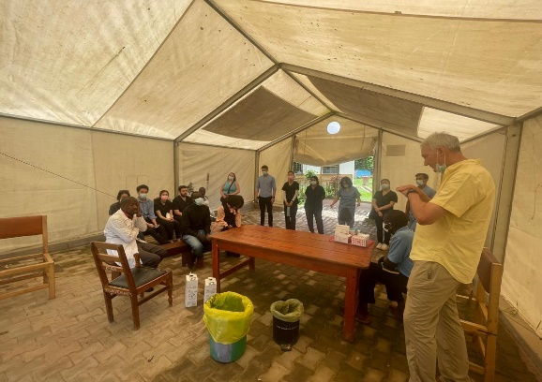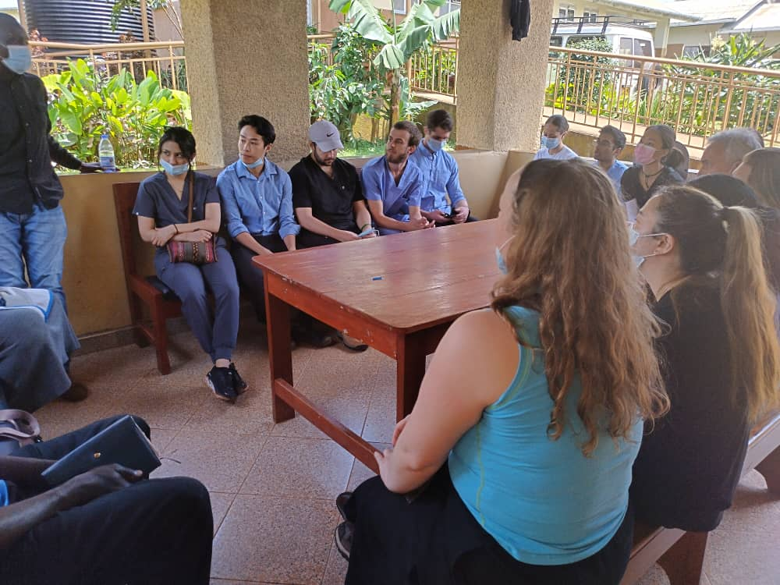

*George Washington Medical students during their visit at Kojja H/C IV*

**School Program**

During the George Washington Medical students’ visit, they were also given a chance to teach health lessons to primary schools as part of our school program. They were able to teach at 4 local primary schools, reaching over 2000students. The medical students chose to present two different topics, providing them with different teaching experiences as they dove into both hygiene and mental health with the students. The hygiene lessons consisted of hand washing, diarrhea/ORS and constructing a handwashing facility for the school to keep and use. On the other hand, the mental health classes included a general introduction to mental health, positive peer relationships and coping skills. The primary school students were fully engaged as the medical students delivered these critical lessons, receiving very positive feedback from school staff.

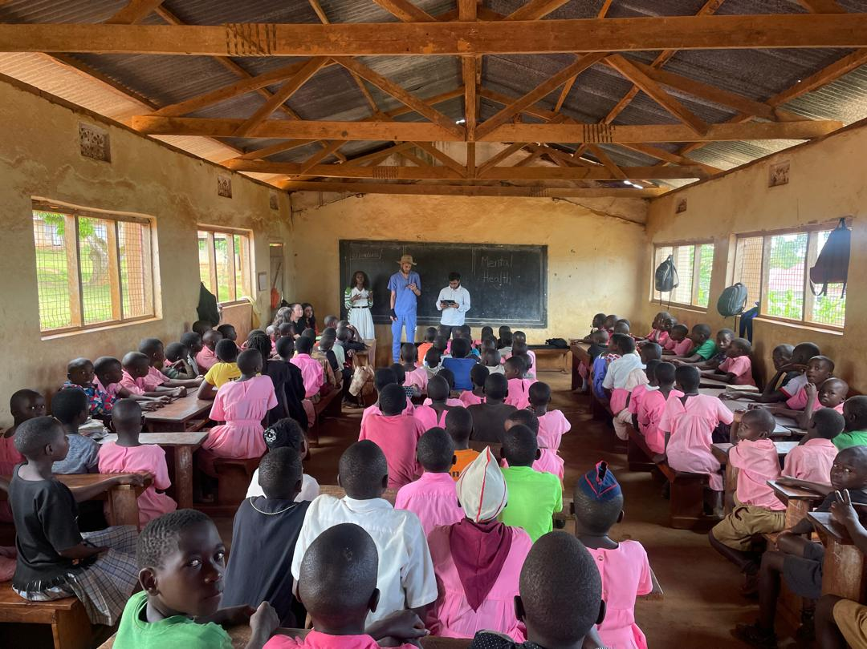

*Two medical Students from George Washington University teaching students of Mwanyangiri Primary School about mental health*

**Hypertension**

The GW medical students actively participated in a community hypertension screening initiative, aiming to identify and raise awareness about high blood pressure among residents in four villages: Golomolo, Bunakijja, Namuyenje, and Nakosi. This effort was made possible through collaboration with VHTs from each village, who played a crucial role in mobilizing community members to participate in the screening.

The students managed to screen approximately 150 individuals from the aforementioned villages, providing each with valuable insights into their blood pressure status. The screening process not only helped identify cases of hypertension but also served as an opportunity for health education, with the students offering guidance on lifestyle changes and risk factors associated with high blood pressure.

Notably, the screenings detected several cases of hypertension, including a particularly concerning case of a 4-month-old pregnant mother with elevated blood pressure. This highlighted the importance of early detection and management of hypertension, especially in vulnerable populations such as pregnant women.

Following the screenings, the students advised individuals with detected hypertension to visit the nearest health centers for further assessment and management. To ensure continuity of care, the VHTs were requested to follow up with the identified cases for support.

The GW medical students’ participation in this initiative not only contributed to the health and well-being of the community but also provided them with valuable hands-on-experience in public health and community engagement. It also demonstrated the critical role that VHTs play in mobilizing communities and supporting healthcare delivery efforts.

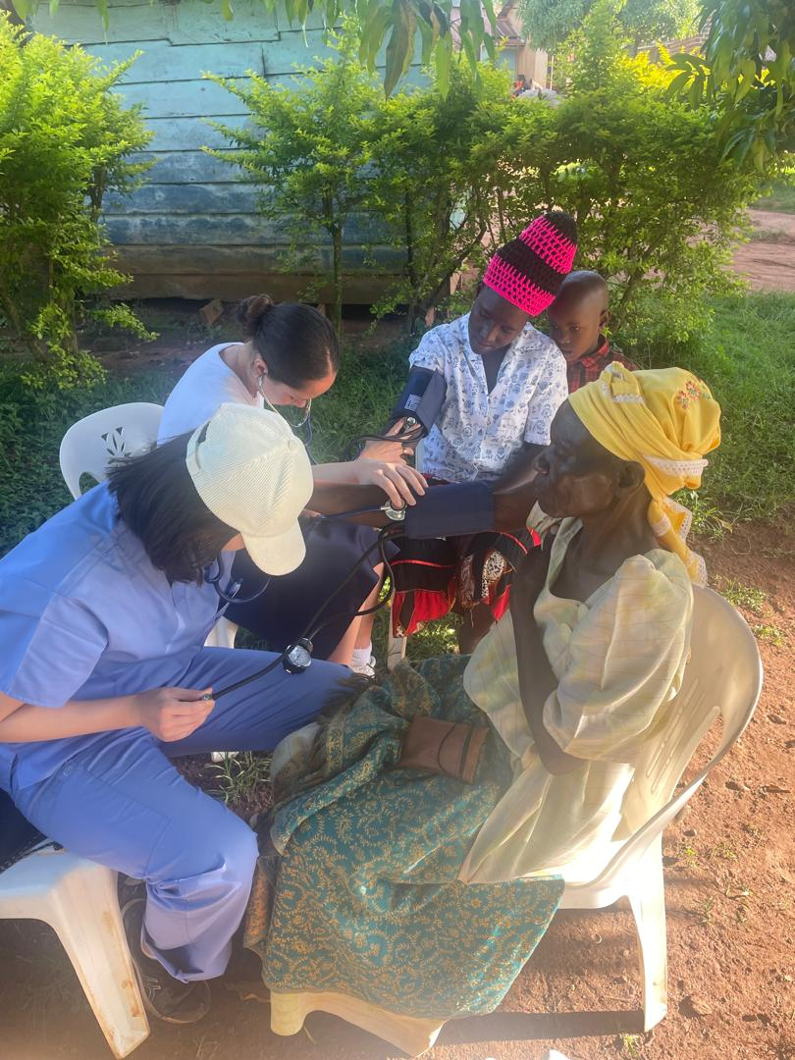

*GW medical students conduct hypertension screenings for community members in Bunakijja village*

**The Cookstove Project**

The GW medical students participated in a cook stove demonstration, witnessing and contributing to the construction of an improved cook stove. They saw a three-stone cook stove, a common traditional cooking method, and an improved cook stove, designed to enhance efficiency and reduce health risks.

The students were able to compare the two stoves, noting the differences in design, functionality, and impact on health and environment. They actively participated in constructing an improved cook stove, asking questions and learning about its benefits.

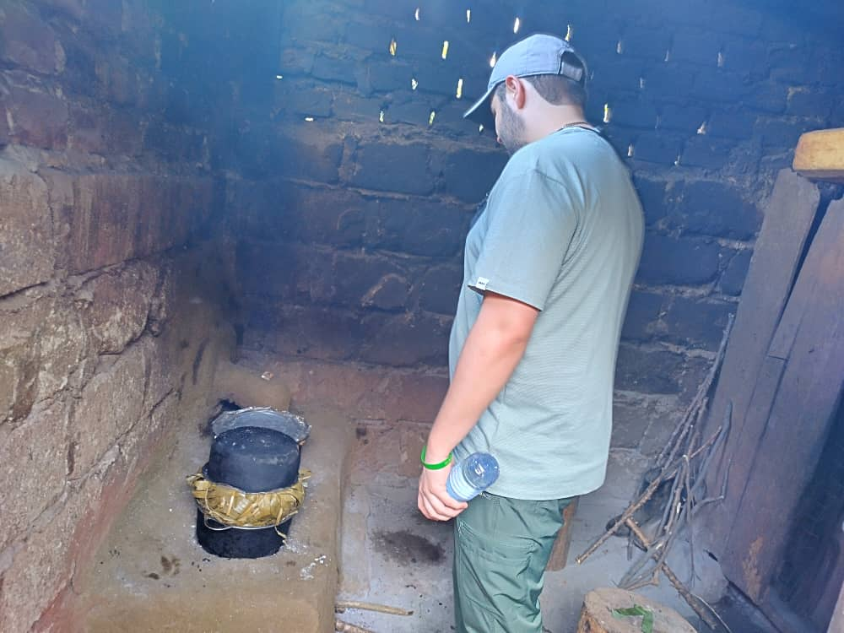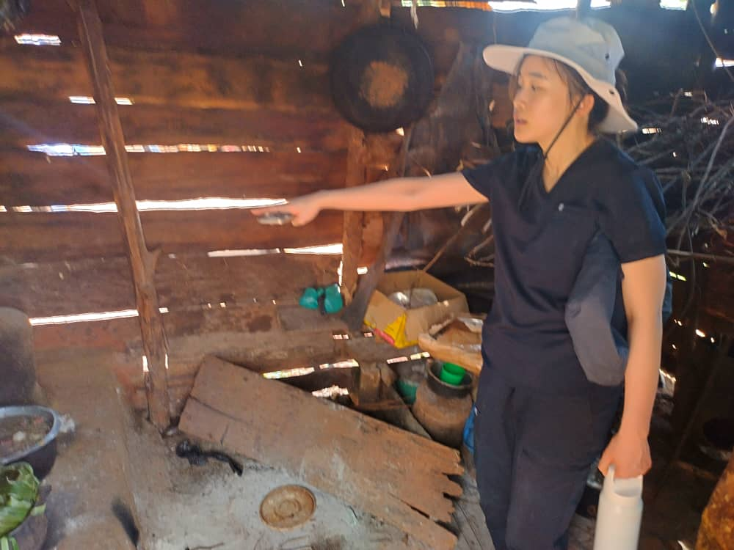

*GW Medical students visiting already constructed improved cook stoves in Kirondo village*

The demonstration, led by Miss Jane Namisango from The Cookstove Project and her team including the coordinator and cook stove masters, highlighted the advantages of improved cook stoves. These benefits include but not limited to reduced smoke emission and related health issues, decreased deforestation, improved heat retention which facilitates boiling drinking water, and reduced accidents like burns.

The students were particularly impressed by the design and functionality of the improved cook stove amazed by the innovation behind its development. Through this demonstration, they gained a deeper understanding of the intersection of health, environment, and technology, recognizing the potential for simple, context-specific solutions to address significant health challenges.

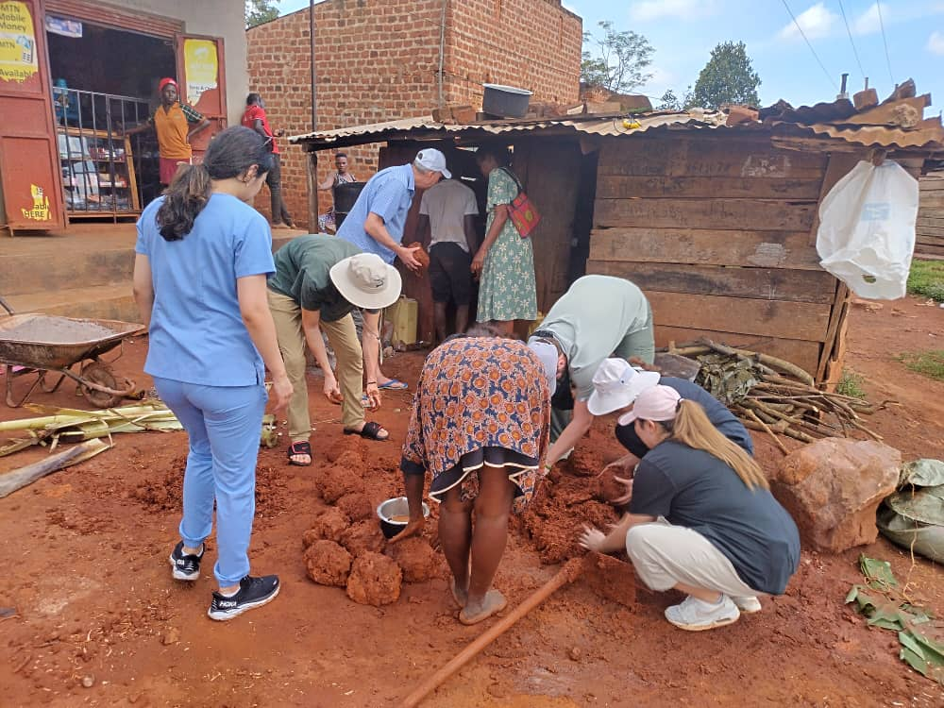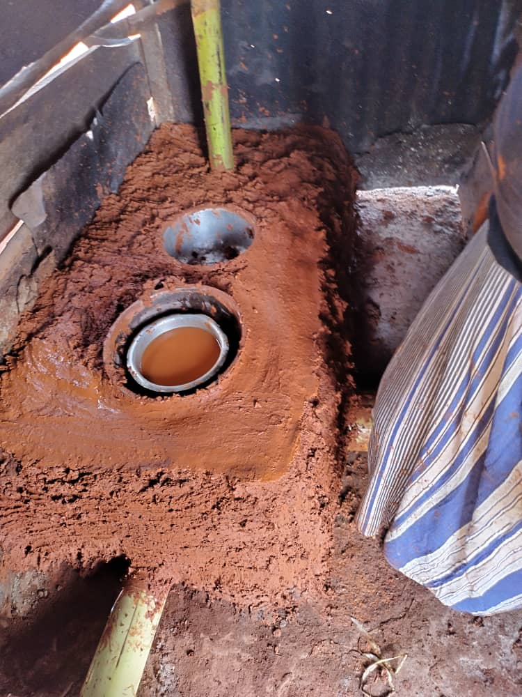

*GW Medical students helping in the construction of an improved cook stove in Kirondo village(L) and an improved cook stove under construction(R)*

**World Malaria Day**

Uganda has the highest incidence of malaria in the world, with malaria accounting for 15-20% of all hospital admissions. In recognition of World Malaria Day, Omni Med in partnership with Sikyomu hosted the Deputy Chief of Mission of the U.S Mission in Uganda, in addition to the Country Director for Peace Corps. The theme for 2025 is “Malaria Ends with Us: Reinvest, Reimagine, Reignite”, which was evident throughout the various activities of the day. Sikyomu opened its gates to the aforementioned guests of honor, local leaders, Peace Corps staff, health center representatives, VHTs and community members to demonstrate the importance of working together in the fight against malaria. The event included malaria education, net distribution and an informative discussion with VHTs regarding their accomplishments and challenges in relation to malaria. Additionally, traditional dances, testimonies and closing remarks from the Deputy Chief of Mission were given to reinvigorate efforts to reduce the prevalence of malaria in Uganda. At the end of the event, over 50 community members from high-priority groups (pregnant or lactating mothers, children under 5 years old and people living with HIV) received education and mosquito nets and the American Embassy in Uganda left with a better understanding of the state of malaria in Uganda and the effects that the US funding cuts has had on the health care system.

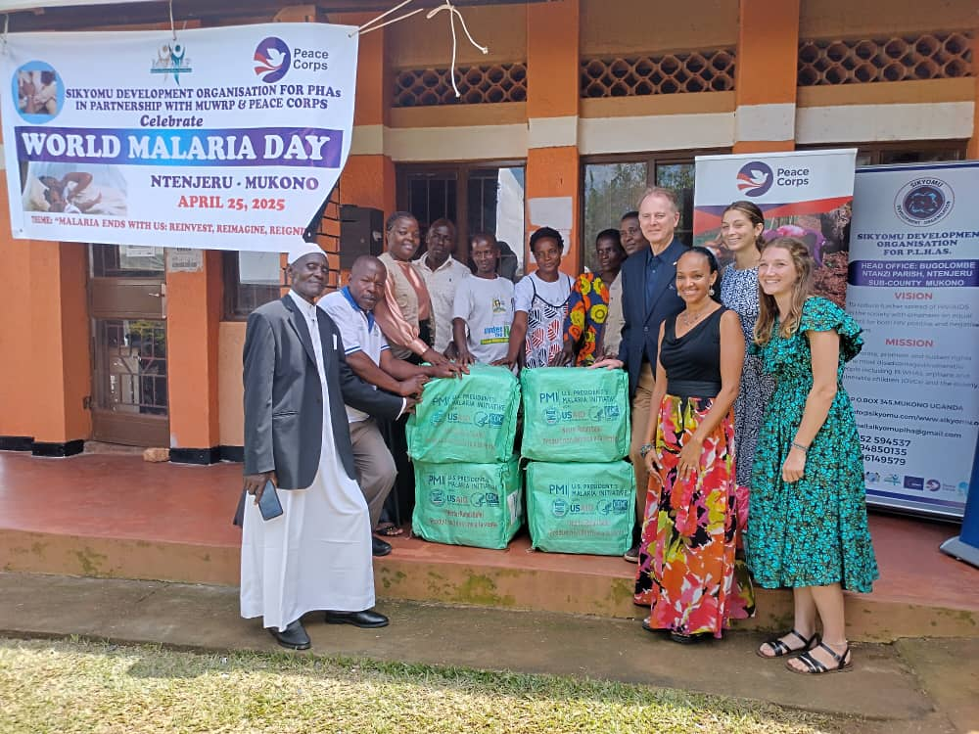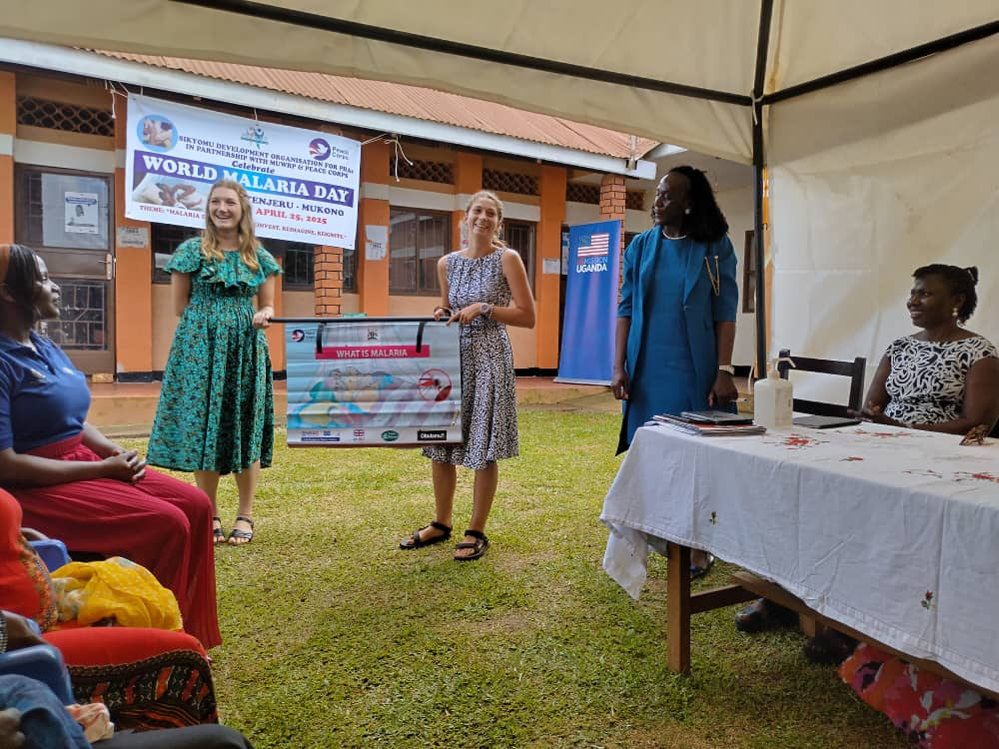

*Our VHTs sharing a photo with the Deputy Chief of Mission of the US, Peace Corps Country Director and Peace Corp volunteers from Omni Med and Sikyomu(L), and the latter sensitizing community members about malaria(R)*

**Stories from the field**

Our staff had the opportunity to meet a 20-year old gentleman in Kisoga Central, who expressed his enthusiasm for following his mother’s footsteps as a Village Health Team(VHT) member. His mother a dedicated VHT for 15 years, has been instrumental in helping community members access essential medicines and providing guidance on their proper use.

Inspired by his mother’s dedication and service, the young man who is currently serving as a VHT aspires to make a similar impact in his community. He shared his passion for helping others access the health care they need.

When asked about what motivates him, he mentioned feeling happy and confident when the people he helps are doing well. The young man’s commitment to serving his community is a testament to the enduring impact of VHTs and the vital role they play in promoting health and well-being at the grassroots level.

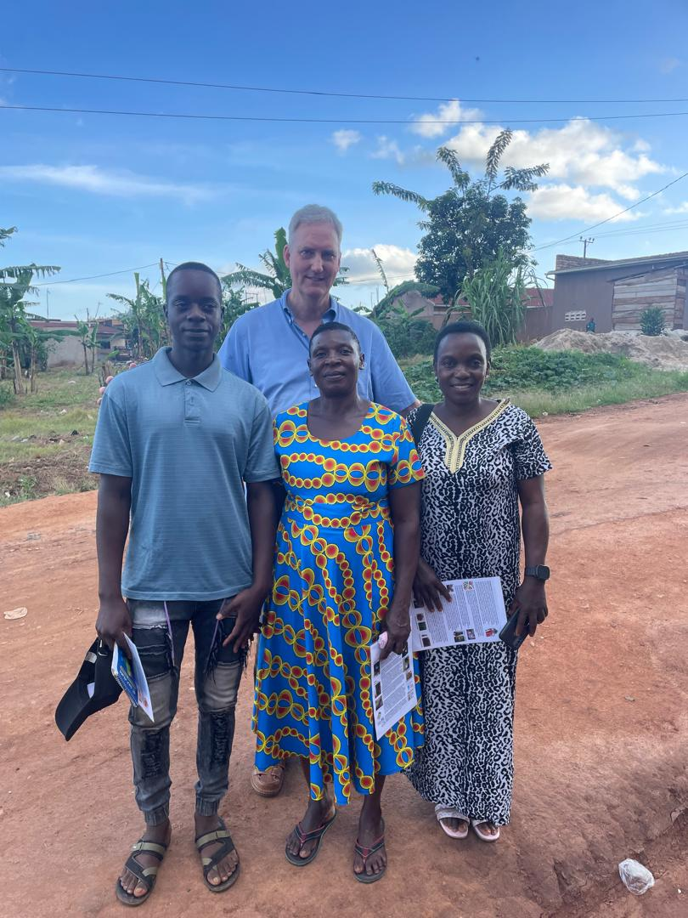

*The 20-year-old VHT(L) alongside fellow VHTs and Dr. O’Neil.*

**AOB**

Omni Med partnered with Climate Inclusion Network and Sir Apollo Kaggwa Primary and Secondary schools to celebrate earth day 2025. Students from both schools were taught the basics of climate change and the importance of preventing deforestation and planting trees. Following the lessons, students participated in planting 20 trees at each school. These trees will be used to provide the students with fruit and shade in the future. Hosting and standing with us during these lessons was “Miss Sir Apollo” and her cabinet. This is a student-elected group of role model students at the school. Working alongside them helped to encourage students to be actively engaged and emphasize the importance of the issue. At the end of the day, two secondary students reached out to inform us that they are interested in starting an environmental club at their school.

We will continue to collaborate and assist them in any way that we can to help preach the importance of fighting climate change among the youth.

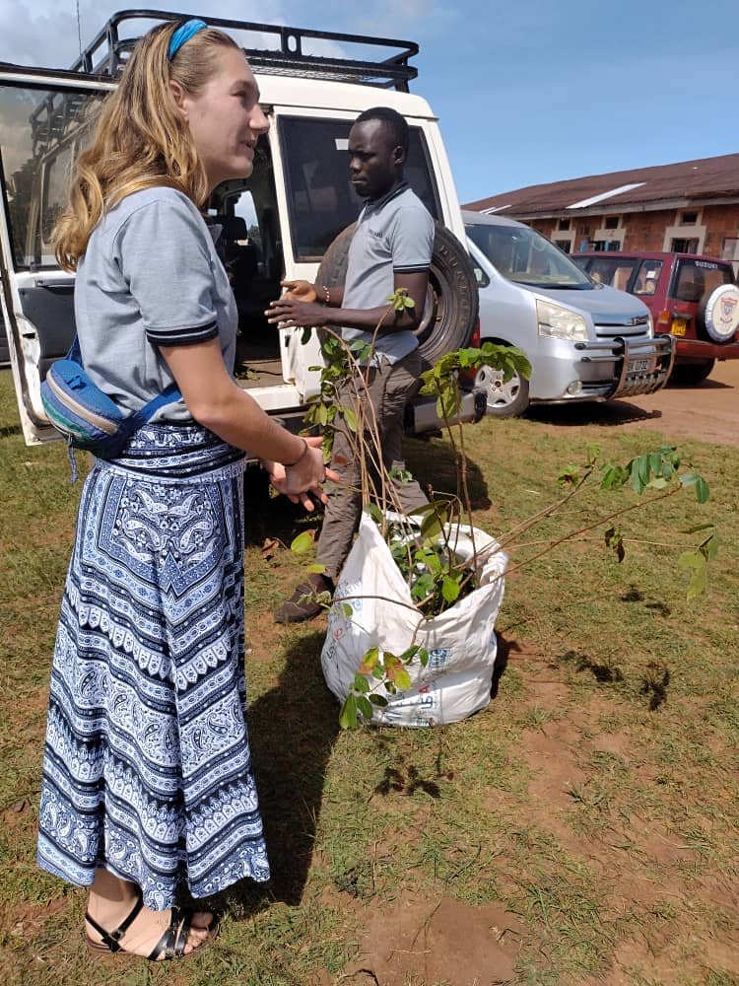

*Kristin and Allan with trees ready for distribution at Sir Apollo Kaggwa Secondary School*