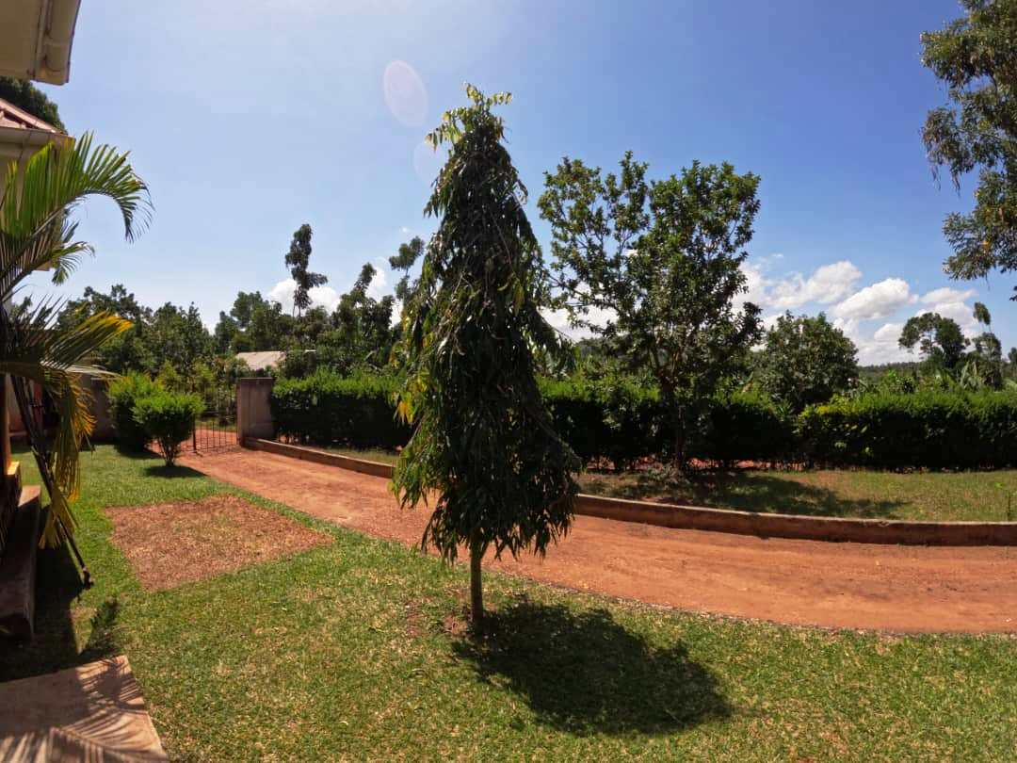

Contents

Students & Visitors……………………………………………………..….. 3

Water Sources………………………………………………………..………5

Home Visits……………………………………………………………………8
Quarterly Trainings…………………………………………..………………10.

ITN Distribution…………………………………………….…………………11

Hypertension…………………………………………………….……………13.
School program…………………………………………………….…..……..15

The Cook stove Project………………………………………………………16

Stories from the Field……………………………………………..…………17

AOB……………………………………………………………………………18
Students & Visitors
This month, we had the pleasure of hosting Dr. Gloria Alvarez for a full day. Gloria Alvarez is pursuing a PHD at NYU School of Global Public Health. She has previous experience working in Uganda, specifically in Wakiso and Masaka, and has also collaborated with the Uganda Cancer Institute. It was great having her with us.
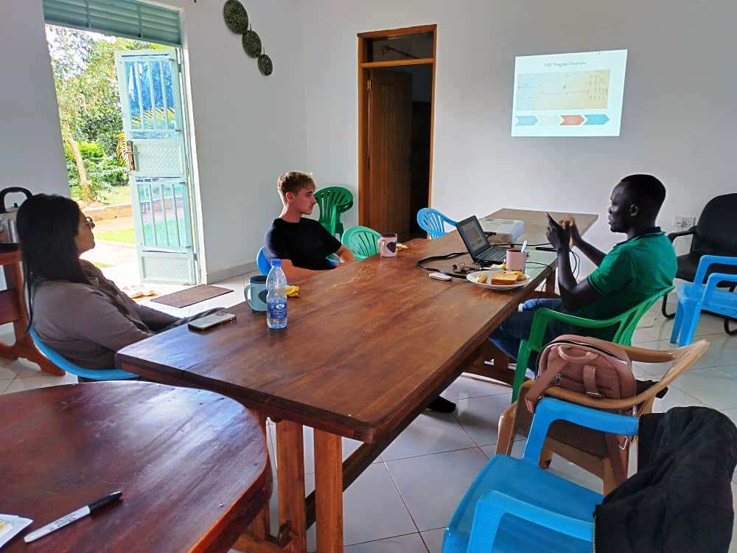
Gloria(L)during the orientation with Quinlan(M) and Allan(R)

Quinlan Supina, a junior at UNC, joined us for a month- long volunteering program. During his stay, he significantly contributed to ITN distribution and malaria education, and actively participated in Omni Med activities including home visits, water source monitoring, and quarterly trainings. His time with us was a positive experience.
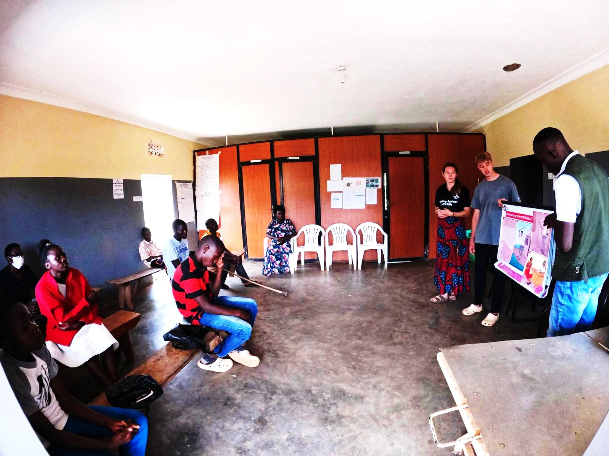
Quinlan conducting malaria education at the health center

We also hosted Naadia a professor at Emory in Atlanta, and her daughter Ariyana for a day. During their visit, they joined us for a home visit in Lwetega village, where they met with local VHTs, observed two households, and saw two protected water sources firsthand. It was a pleasure hosting them.
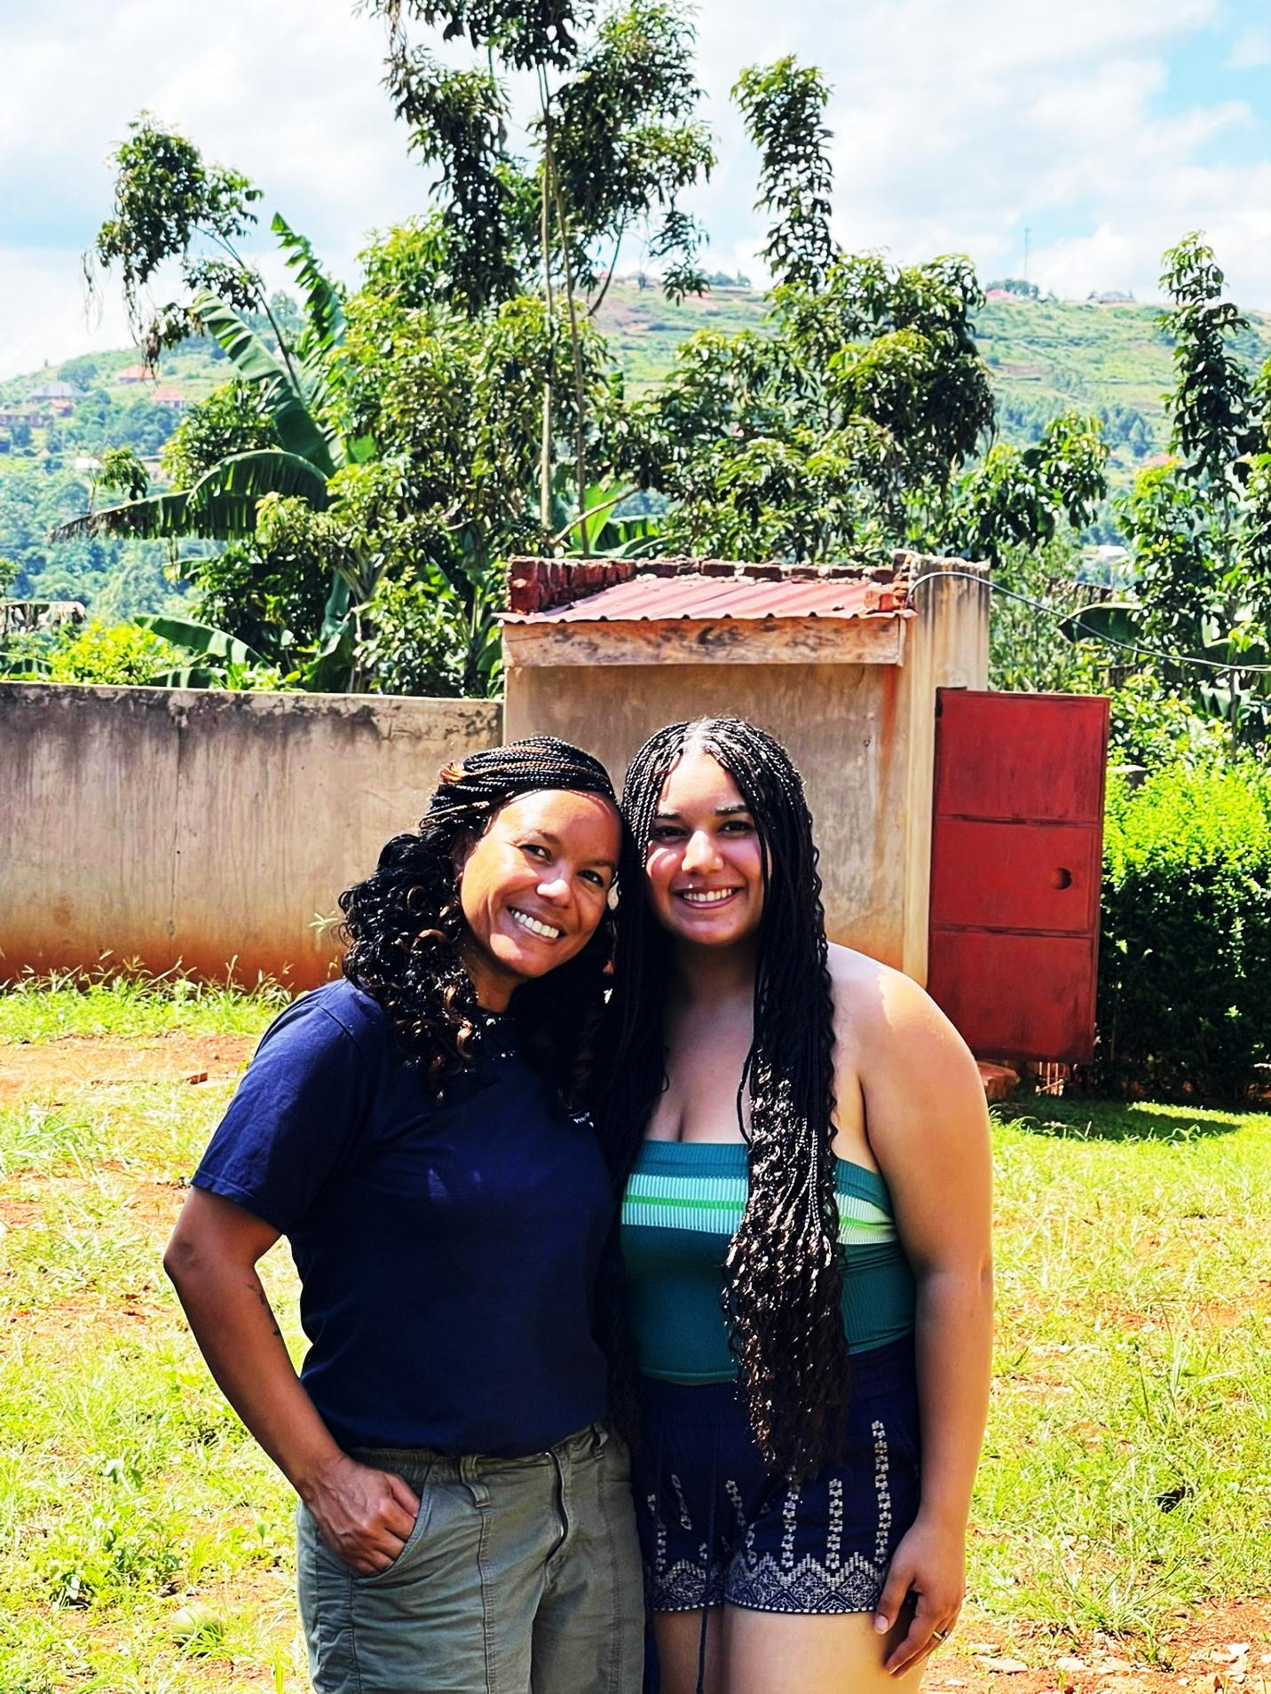
Naadia(L) and Ariyanah(R) at Omni Med premises
Towards the end of the month, Lucas Allen from GWU SMHS joined us. His primary focus for the next month will be on the emerging EMS system and the VHTs, where hell be looking at how best to prepare VHTs to interact with the EMS providers, what educational programs will be most important, and future plans. He is also participating in various Omni Med activities. Its great having him on board.

Water Sources
Omni med staff visited three water sources in the month of June.
The first water source we saw this month is called Kabiwogo water source. Kabiwogo is a protected water source situated in Namina village, supplying water to three villages that is Namina, Wabinyira and Nawanjuki including a local primary school. Constructed by the district in 1994, it remains in great condition partly because of the diligent maintenance by the community, who rely heavily on it as their sole protected water source.
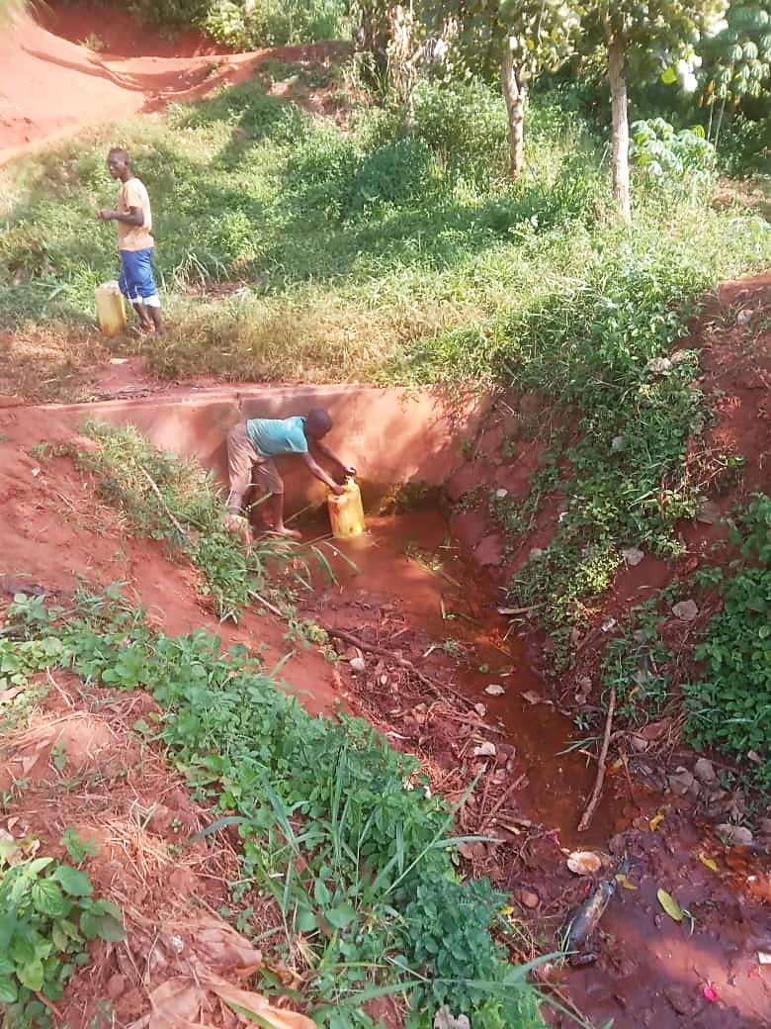
Children collecting water from Kabiwogo water source

Our staff also visited Nteete water source, a protected water source in Luga, which was the 19th water source constructed by Omni Med in 2015. After being damaged by cattle that crossed over and broke the top part of the source, Nteete water source was renovated by the community and is now working effectively. Over 50 households collect water from it.
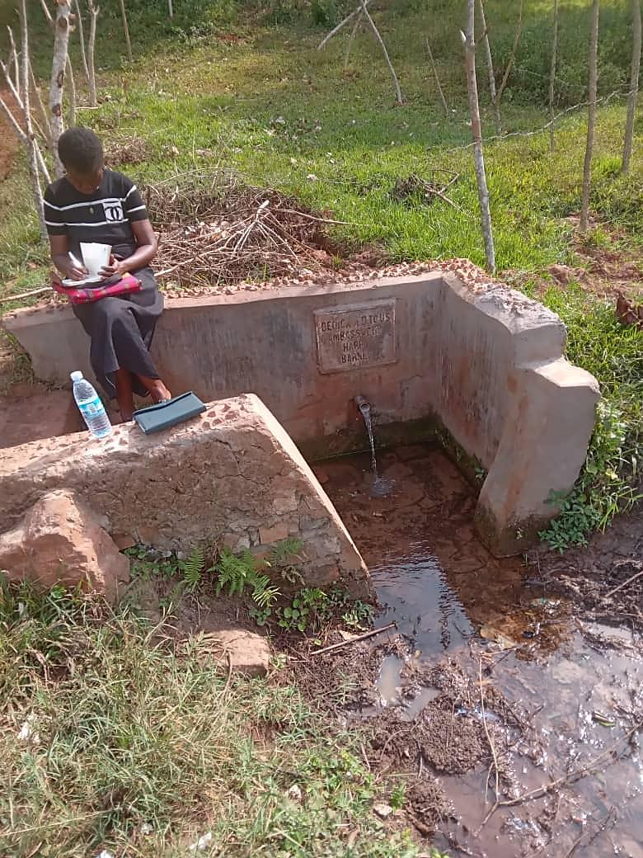
Cissy at Nteete water source

Lastly, we visited Nanono a protected water source in Luga village, which was the 16th water source to be constructed by Omni Med in 2016. It is still in great condition serving over 70 households.
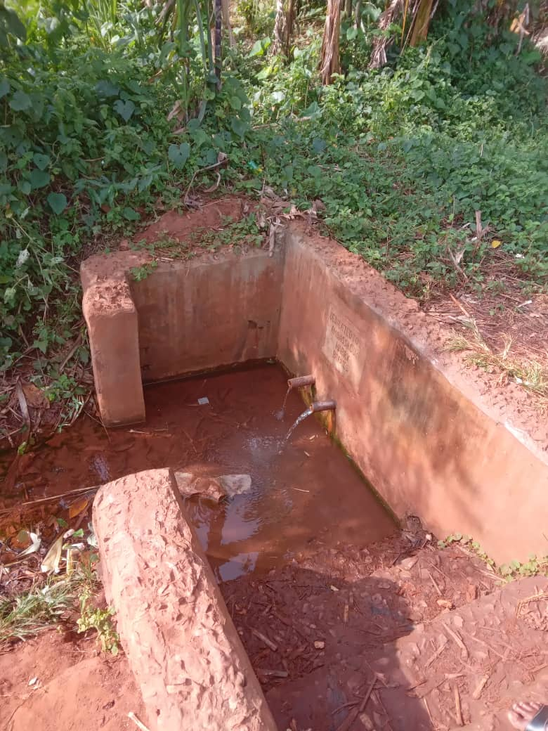
Nanono protected water source found in Luga village

Home visits
This month we held 7 home visits and saw 17 VHTs.
Breakdown of home visits for June
DATE | VILLAGE | NO. OF VHTS SEEN
4- JUNE | GOBERO | 2
5- JUNE | BUYUNJU | 2
10- JUNE | NAKIBANO | 1
11- JUNE | LWETEEGA | 3
16- JUNE | KABANGA | 1
17-JUNE | NGOMBERE | 5
23- JUNE | BUWUJJA | 3

Average number of households that VHTs serve: 45
Average number of years each VHT has served in their village: 15
Commonest occupations of VHTs: Farmers, Small business owners
VHT volunteering roles at Health Centers: Educating pregnant women about health pregnancy, Assisting health care workers in vaccination, Screening TB, Providing support at the ART clinic, Monitoring HIV patients, Guiding patients, Conducting family planning education.
Common changes: Increased number of pregnant women delivering at health centers, Increased number of people inquiring health information from VHTs, More people practice what they are taught during health education, Increased construction of drying racks, Decrease in diseases like malaria and diarrhea, Increased participation in immunization programs, Increased use of mosquito nets, Increased construction of pit latrines, Increased number of people testing and searching for health information at health centers.
Suggested topics by the VHTs for training: Nutrition, Tuberculosis, Malaria, Mental Health Coping skills, Pneumonia, HIV/AIDs, Mental Health, Diabetes, Hypertension, Family planning, Malaria.

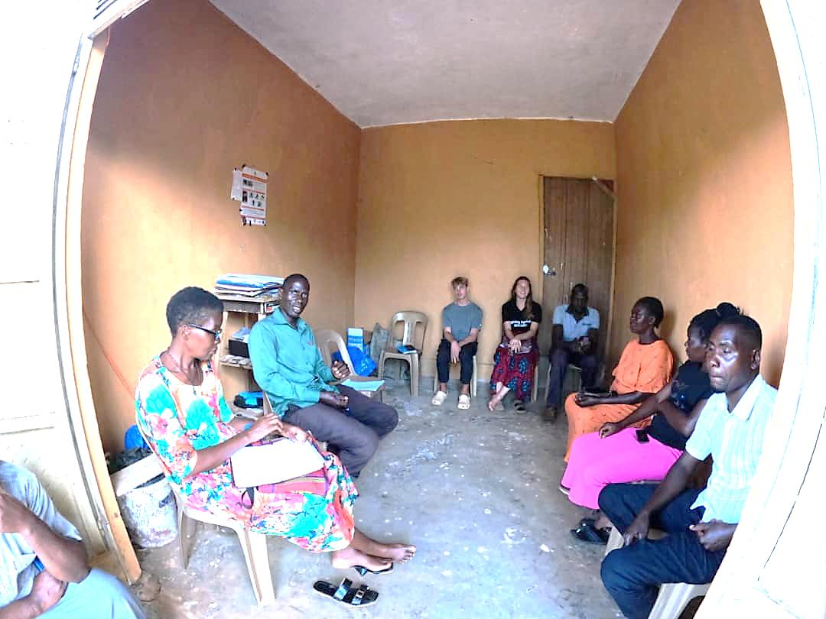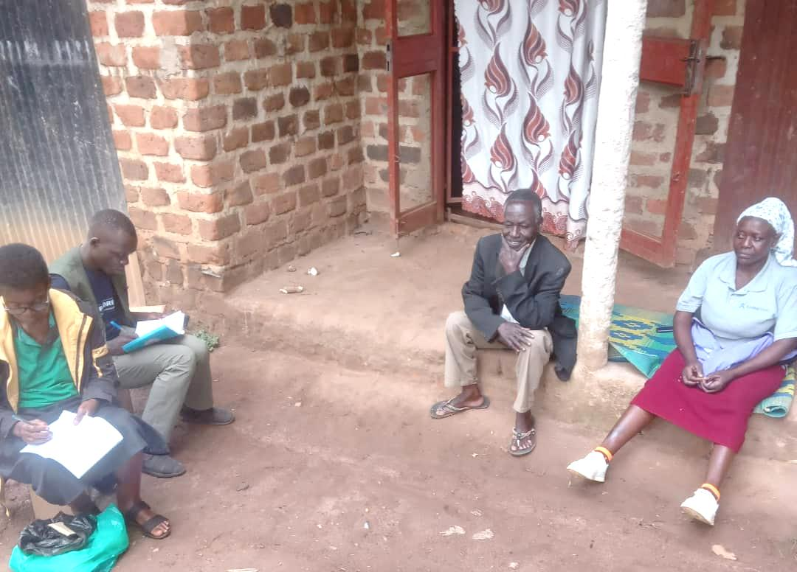
Omnimed staff meeting with VHTs during home visits

Quarterly Trainings
Omni med staff held one quarterly training in the month of June.
List of Quarterly Trainings held in June
DATE | PARISH | NO. OF VHTS | TOPIC
12- JUNE | NAMUYENJE | 32 | MENTAL HEALTH COPING SKILLS

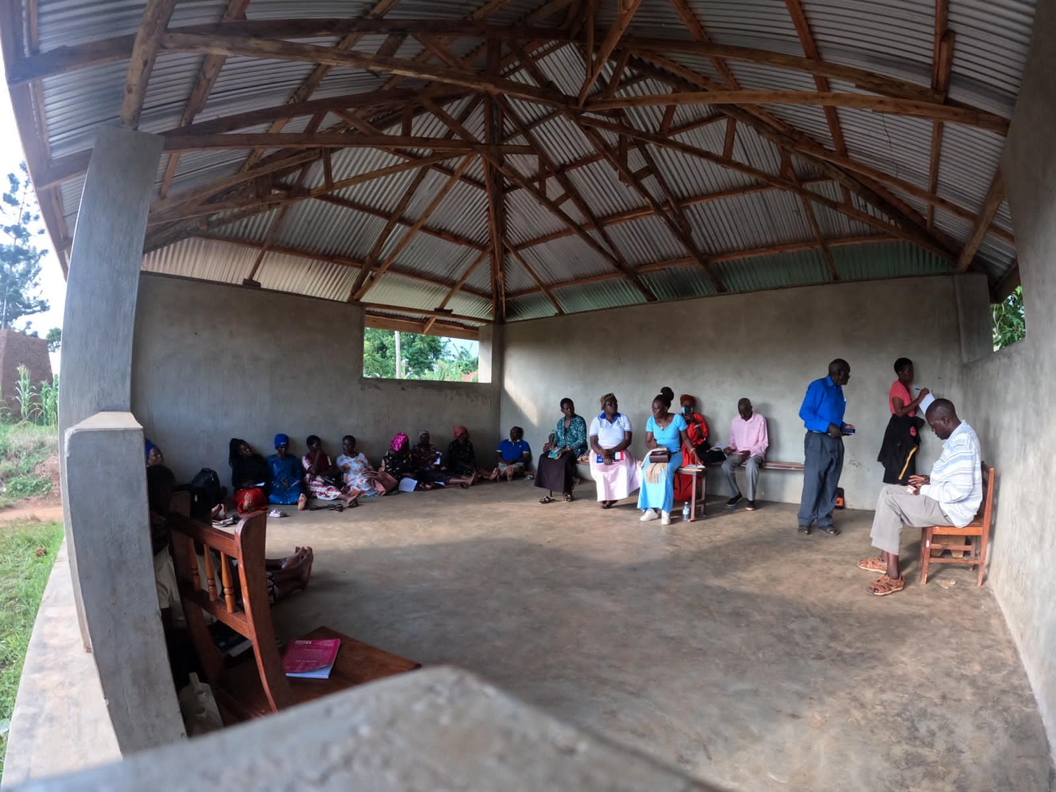

Namuyenje VHTs during the quarterly training

ITN Distribution

Mosquito Net Distribution is in full swing. This month, the Omni Med team worked alongside Public Health student Quinlan to address the high rates of malaria in our communities. Uganda holds the highest incidence rate of malaria in the world, accounting for an estimated 18,000 deaths in 2022. Omni Med received 1,800 long lasting insecticide treated nets through Peace Corps PMI (Presidents Malaria Initiative) partnership. Net distribution, paired with malaria education has been taking place in communities and at the health centers and schools, as outlined below.

 | Beneficiaries
Location | Pregnant/ Breast-feeding mothers | Children under 5 years | People Living with HIV | Other vulnerable people | Total
Makata village | 22 | 160 | 0 | 6 | 188
Seeta Nazigo H/C III- ART Clinic | 3 | 3 | 28 (2 also under 5years) | 0 | 34
Seeta Nazigo SDA Primary School | 1 | 111 | 0 | 0 | 112
Seeta Nazigo C/U Primary School | 1 | 23 | 0 | 76 | 100
Ngombere village | 10 | 171 | 37 | 6 | 224
Kisoga Outreach | 13 | 24 | 5 | 0 | 42
Total | 50 | 492 | 70 | 88 | 702

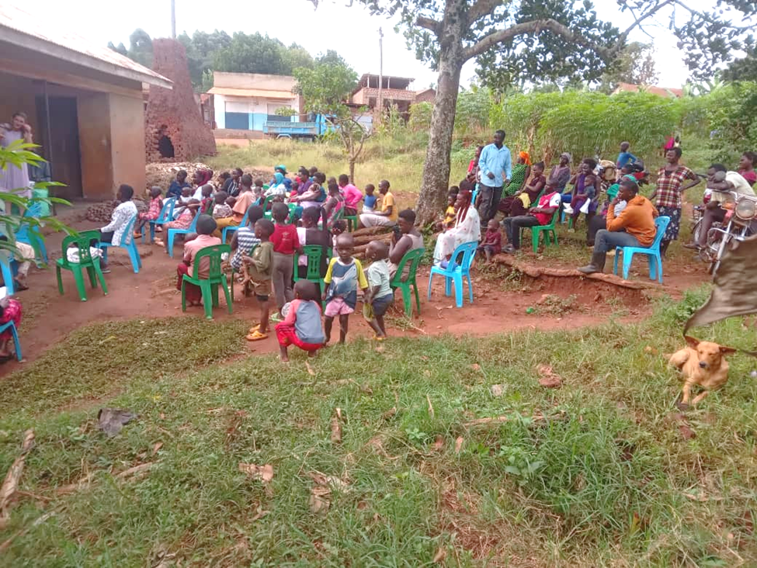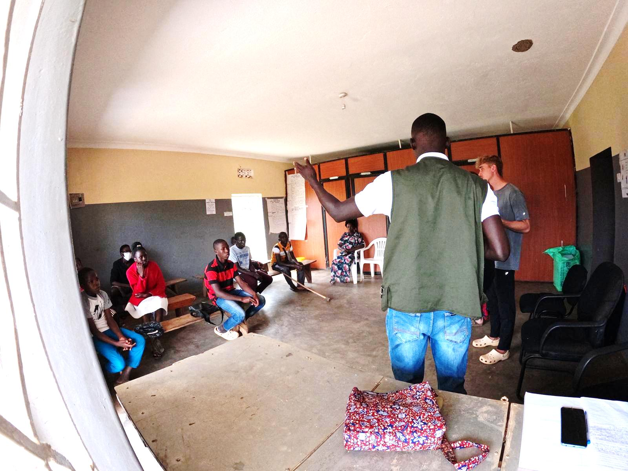

Quinlan, Allan and Kristin meeting with community members for mosquito net distribution and malaria education.

Hypertension Program
This month, our staff has been conducting hypertension follow ups and monitoring to support VHTs in maintaining their screening skills, while also checking the condition of the blood pressure cuffs. Additionally, the monitoring will help identify areas for refresher training, and provide ongoing support to VHTs in managing hypertension cases. During monitoring, our staff observed that VHTs with more experience and skills tended to be those who had more opportunities to practice, such as actively screening patients at health centers or individuals by moving door-to-door.

Hypertension Follow-ups done this month
DATE | VILLAGE | NO. OF VHTS
18TH JUNE | BUMBAJJA | 2
18TH JUNE | NASSAKA | 1
18TH JUNE | NSONGA | 1

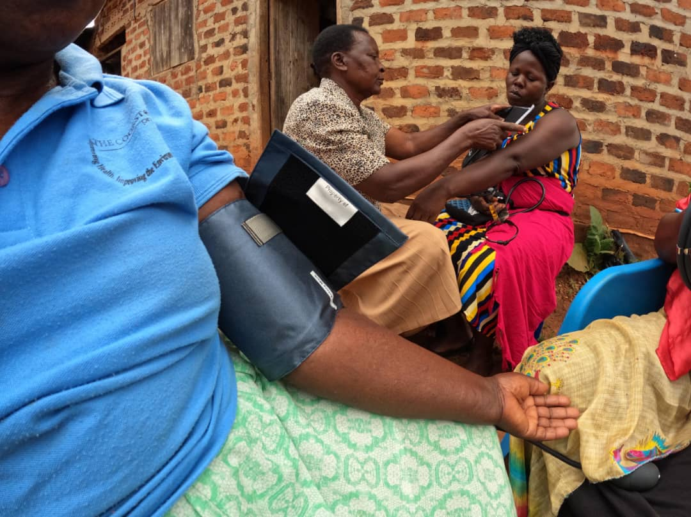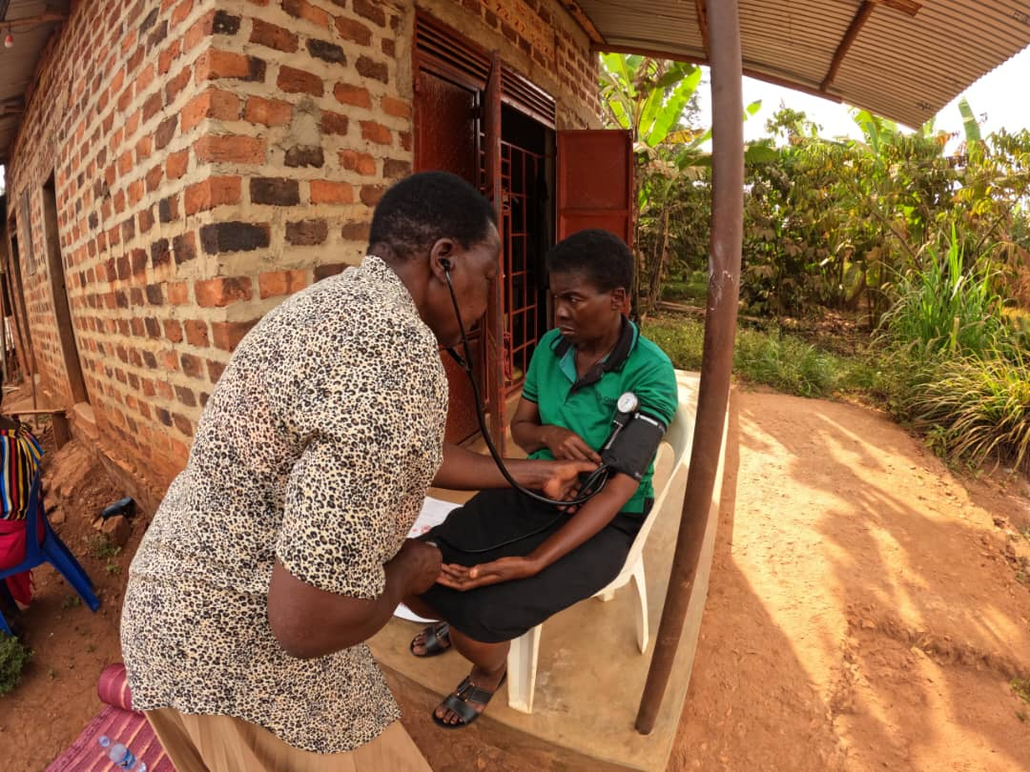
Cissy and VHTs during hypertension follow-ups

In addition to follow-ups, our staff conducted outreaches to screen community members for hypertension, promoting early detection and intervention. This not only helped identify individuals with elated pressure but also raised awareness about hypertension prevention and management. Community members were encouraged to maintain healthy lifestyles such as regular exercises and balanced diets.

Our staff noted variations in blood pressure levels among different communities, with Makata and Kisoga residents generally having better readings than Ngombere residents. These variations are partly attributed to lifestyle habits, access to health care services and awareness and management of hypertension.
Summary of community hypertension screenings conducted this month
DATE | VILLAGE | NO. OF PEOPLE SCREENED | NO. OF REFERRALS
22ND - JUNE | NGOMBERE | 35 | 9
24th - JUNE | KISOGA | 41 | 2
26TH- JUNE | MAKATA | 34 | 1

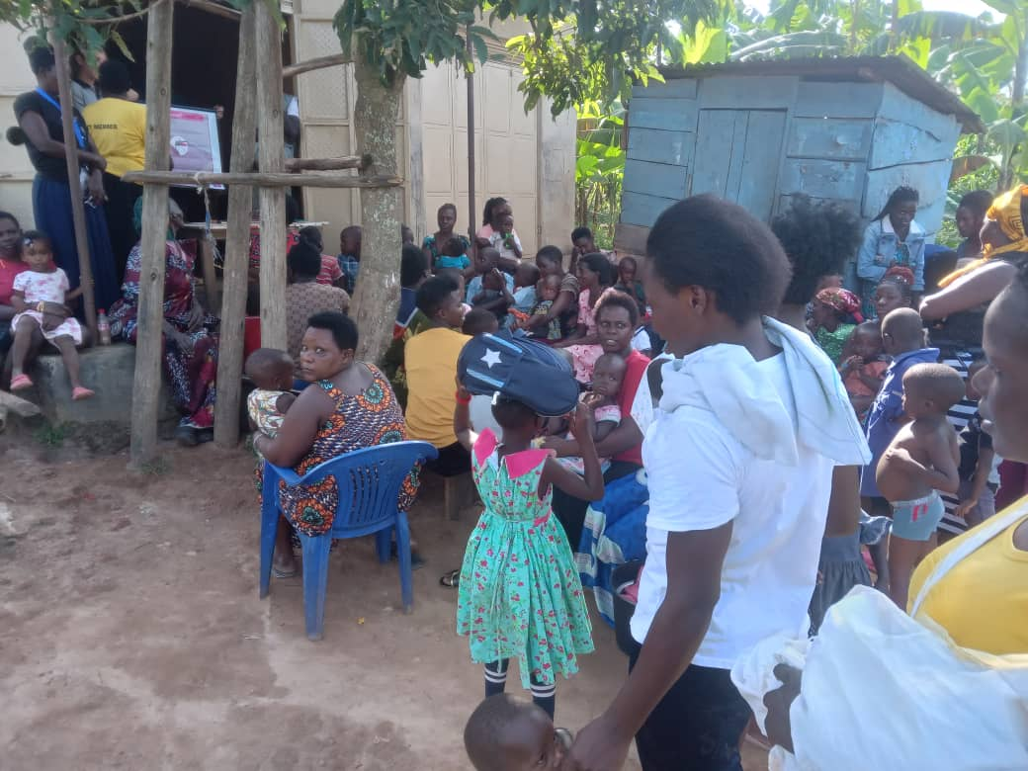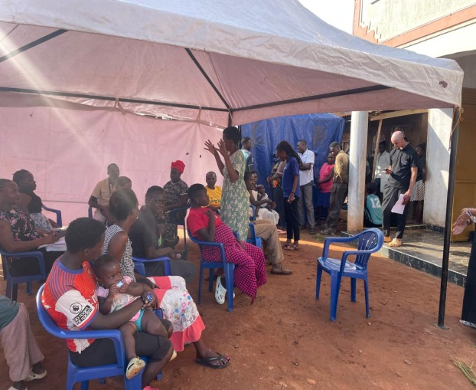
Community members gathered for hypertension screening during the outreaches

School Program
Continuing with the malaria theme, Omni Med staff and our volunteer Quinlan visited two neighboring primary schools in Seeta Nazigo village. They taught students and teachers about malaria, including prevention, treatment while introducing the newly available malaria vaccine and addressing common myths. The lesson concluded with a participatory game to help illustrate malaria transmission and the importance of sleeping under a mosquito net. Finally, nets were distributed to students who were lacking them in addition to students with younger siblings in the target population.
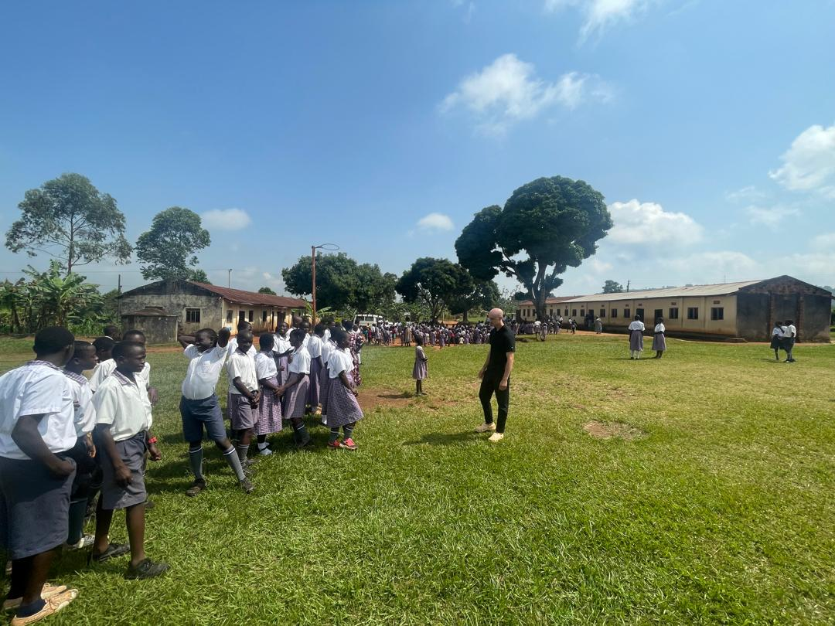
Quinlan and students of Seeta Nazigo C/U pimary school

The Cook stove Project
Our staff participated in a cook stove demonstration at Kalengera village led by Jane form The Cook stove Project and one cook stove master, further showcasing the benefits of improved cook stoves. Compared to the three stone traditional cooking method, it is designed to be more efficient, safer, and environmentally friendly.
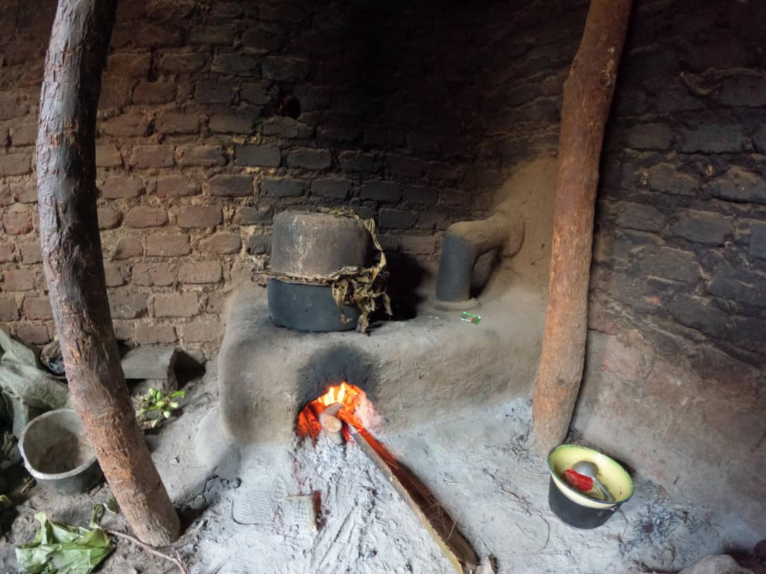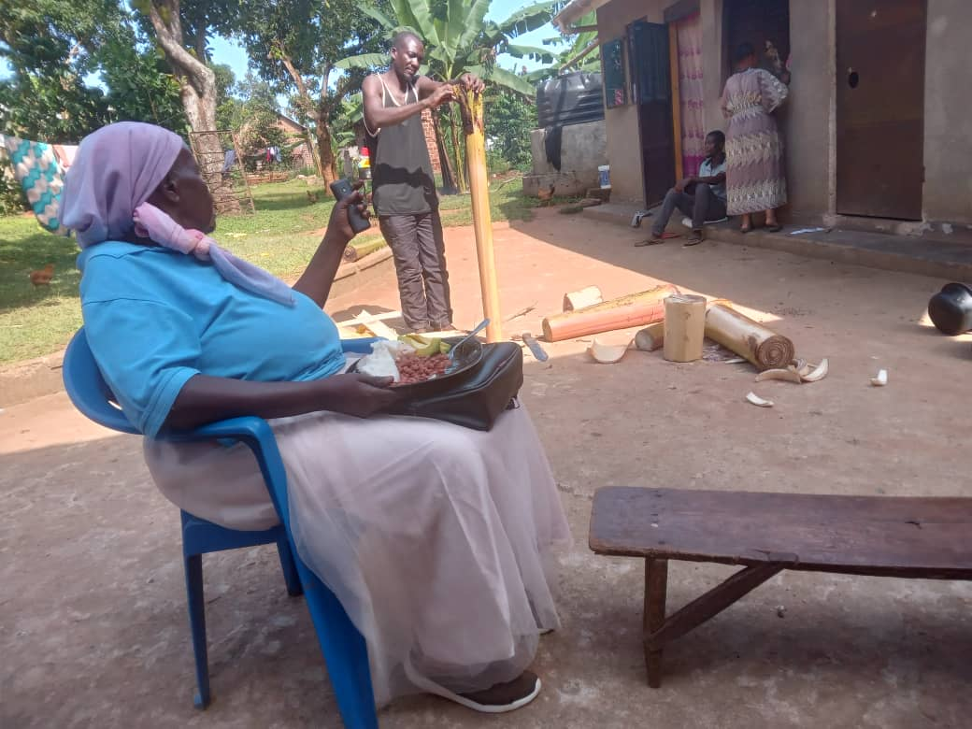
An already constructed improved cookstove(L) and Jane with a cook stove master during the cook stove demonstration(R)

Stories from the field
A VHT from Mpunge expressed concern that some health care workers dont adequately acknowledge or appreciate their contributions, particularly with regards to referrals and health reports from their villages. The VHT requested support from Omni Med staff to address this issue and ensure their efforts are recognized and valued. On the contrary, many other VHTs have noted improved relationships between health care workers at health centers and VHTs.
A VHT from Kabanga village requested recruitment of additional VHTs to support their work, as the village is too large for the current two active VHTs to manage effectively. Initially, four VHTs were trained, but three lost interest and discontinued their roles, leaving only one active VHT who was later joined by another community member but hasnt yet received formal training. Additionally, the VHT felt frustrated with organizations that promise stipends but dont follow through.
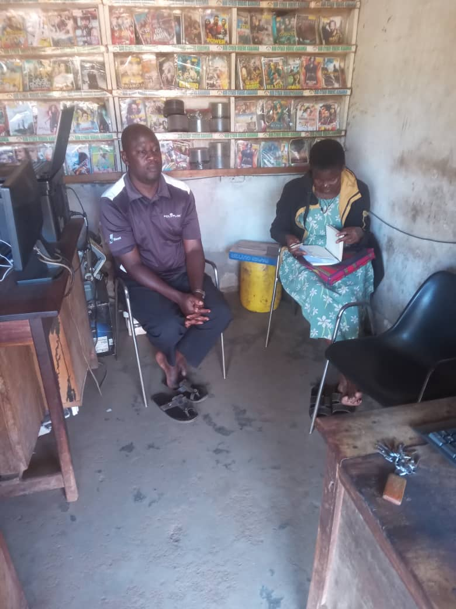
Cissy interacting with a VHT

AOB

Omni Med partnered with Sikyomu during a community outreach centered on HIV. The outreach was located in Kisoga and targeted individals 15-39 years old. Services included HIV testing, STI testing and treatment, condom distribution and health talks such as mental health and malaria. Omni Med also provided hypertension screening and mosquito nets for those within the target group. There is a plan underway to replicate this outreach in different areas.

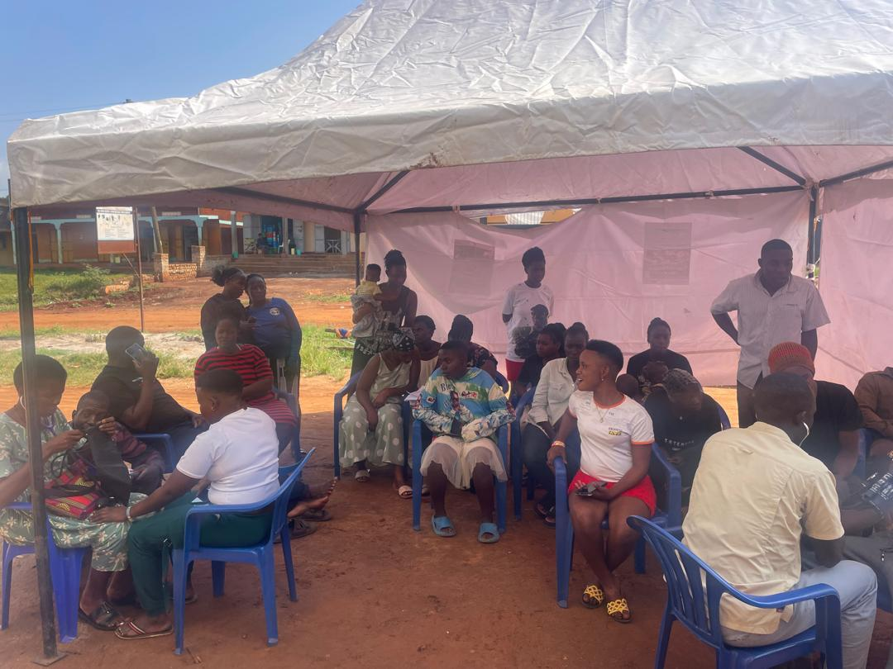

Community members gathered for the outreach

